|  |
| --- |
| **Github Link-**  **https://github.com/jyothiarunkr/simplilearn-phase4-kitchen-story.git**  **Output screens**  **KITCHEN STORY** |
| **AN E-COMMERCE WEB APPLICATION**  **FOR A SMALL RETAIL FOOD STORE**  **Dr. Jyothi N.M.** |

**Output Screens**

# 1. Home Page

The home page of this application is shown in Figure 10. It is the start page of the application where all available products with a quantity greater than zero are displayed. Also, customers or visitors to the e-commerce store can browse available products by category. On this page, customers can add products to the shopping cart, and there is a link provided to view products added to the shopping cart. More so, a link is provided

for customers and visitors to display and fill the email subscription form in order to subscribe to an email list for special announcements and offers.

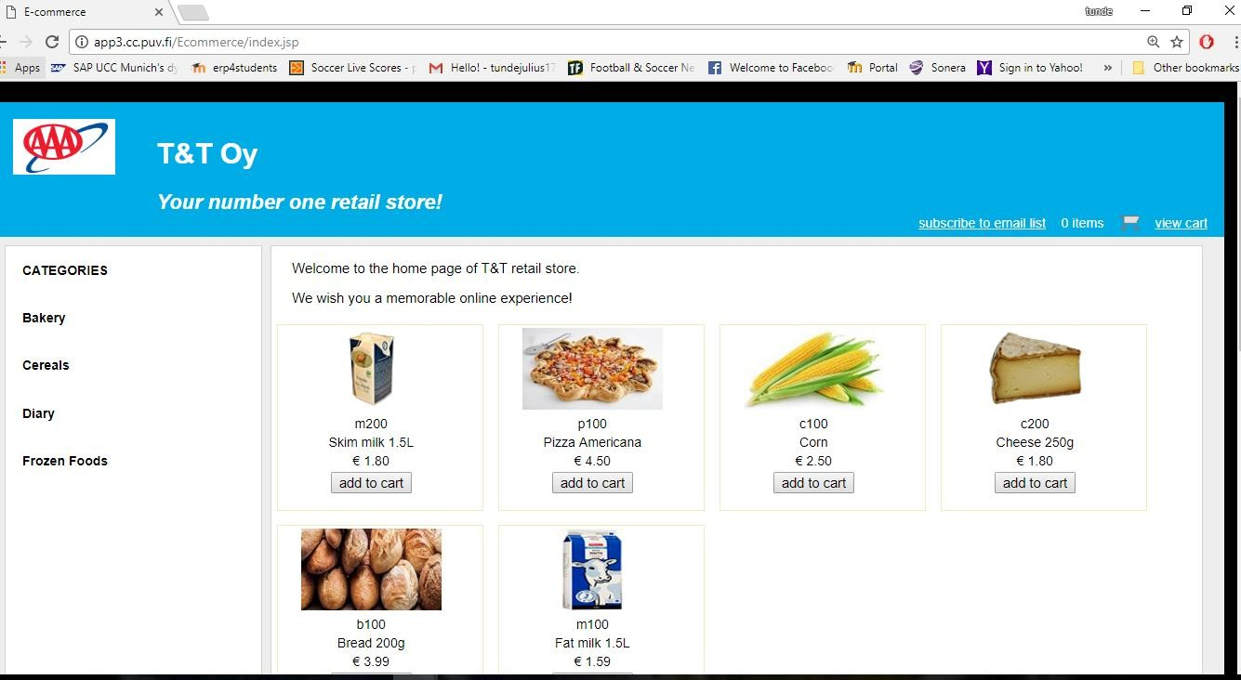

**Figure 10.** Home page.

## Shopping Cart Page

The shopping cart page of this online store application is as shown in Figure 11. This page is accessed when a user clicks the view cart link to show the information of all the products added to the shopping cart. On this page, the quantity of any product in the cart can be changed and updated. Any product can be removed from the cart and the cart can be emptied as well. There are links provided for browsing available products by category and also to return to the home page of the application. In addition, the PayPal check out button is displayed on this page if the shopping cart is not empty.

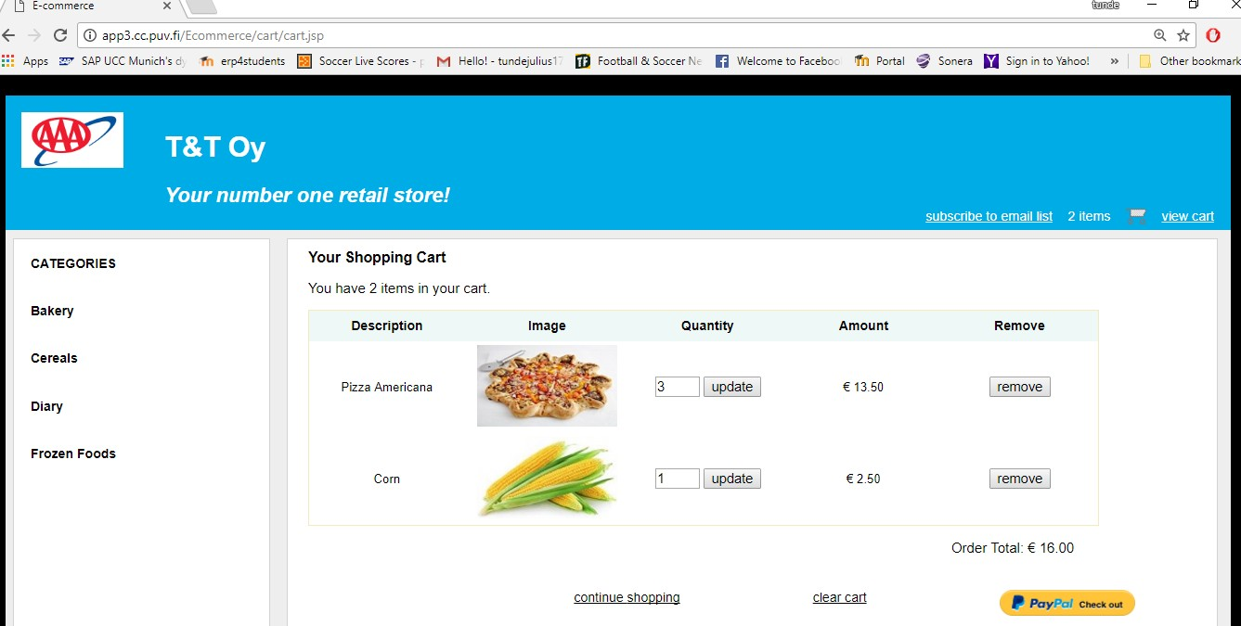

**Figure 11.** Shopping cart page.

## 

## Email Subscription Page

Figure 12 shows the email subscription page. This page is accessed when a user clicks the subscribe to email list link to display the email subscription form where a user can enter and submit the subscription information. The form does not accept null or empty values. After a successful subscription process, the user is redirected to a confirmation page which displays a confirmation message.

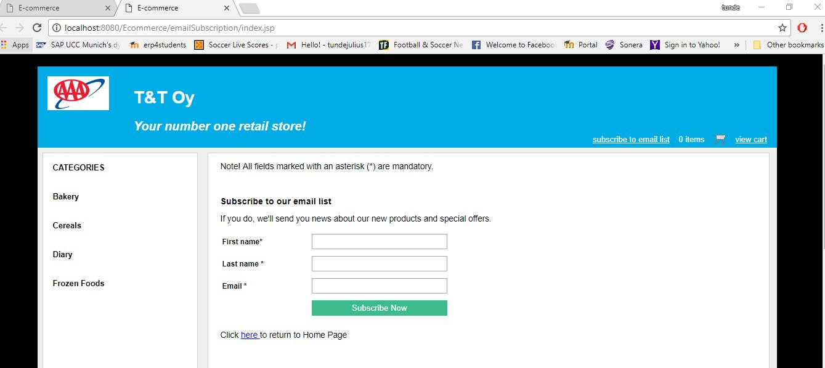

**Figure 12.** Email subscription page.

## Order Review Page

The order review page of this application is as shown in Figure 13. This page shows an order review just before confirmation. It displays the customer’s shipping address, order amount, currency and payment status of the order. A button is provided to confirm the order.

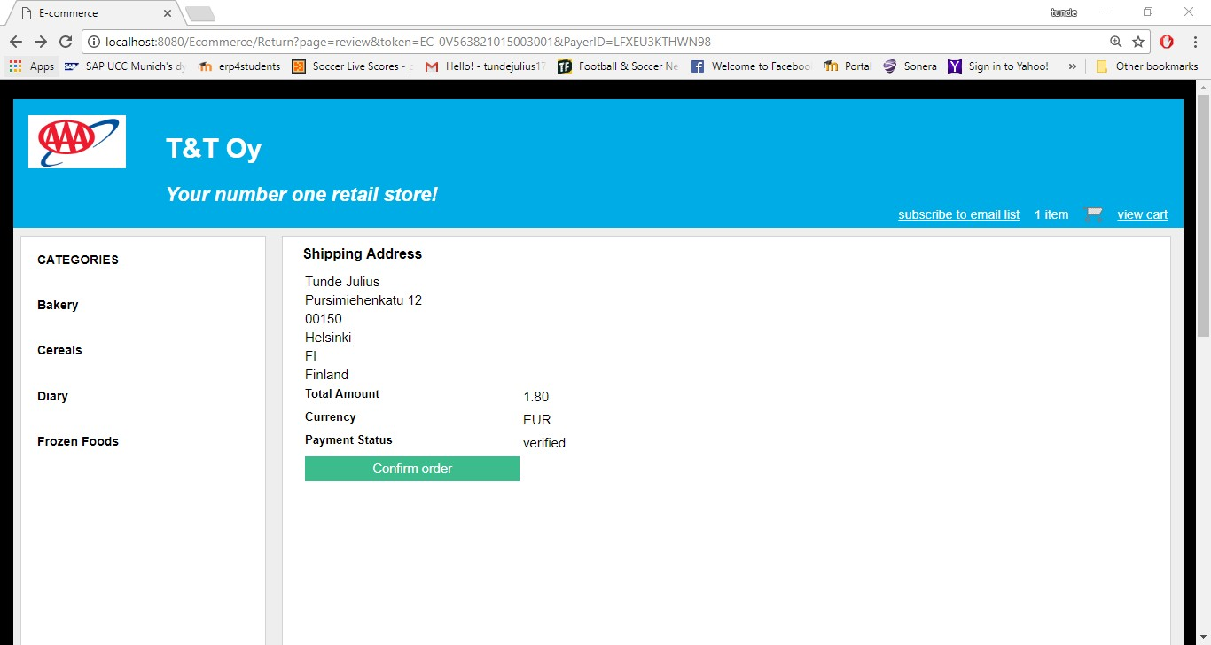

**Figure 13.** Order review page.

## 

## Order Confirmation Page

Shown in Figure 14 is the order confirmation page of this application. This page displays a confirmation message after a successful order process. It shows the customer’s shipping information and the details of the payment.

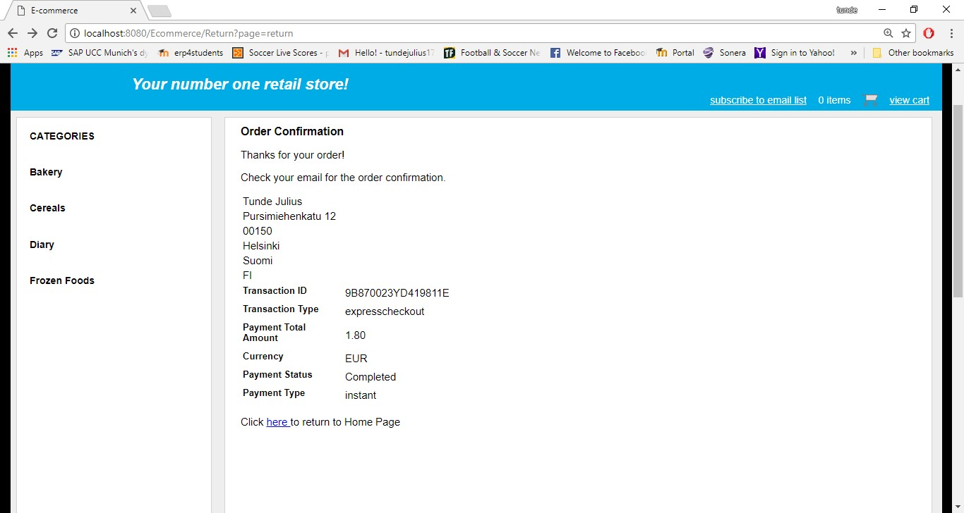

**Figure 14.** Order confirmation page.

## Admin Login Page

Figure 15 shows the admin login page. This page presents the admin login form where a user can enter and submit login credentials for authentication purpose. It is actually a customized form for form-based authentication method provided by Apache Tomcat servlet container. More so, it is not possible to enter null or empty string values on the form. The page is displayed whenever a user tries to access the admin page of the application which is restricted and can only be accessed by authorized users. If the authentication fails the same page is displayed again but with an error message.

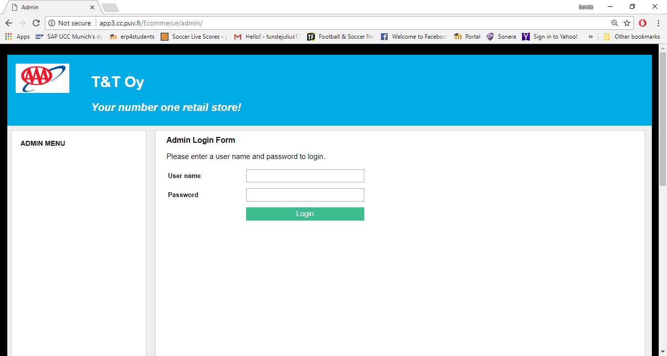

**Figure 15.** Admin login page.

## Admin Menu Page

The admin menu page is shown in Figure 16 and it is displayed when a user has been successfully authenticated. The page is the gateway to the administrative tasks for the admin. The links for these tasks have been categorized so that they can be easily accessible.

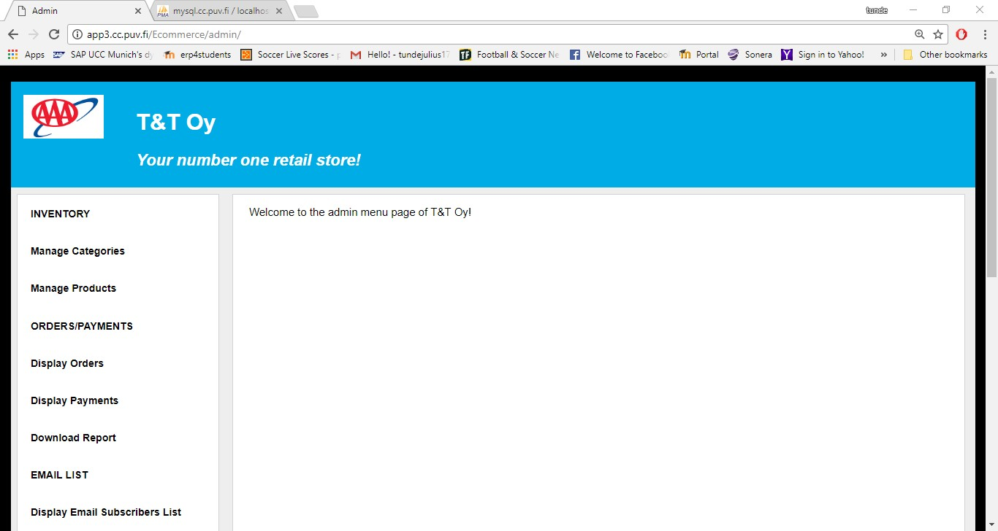

**Figure 16.** Admin menu page.

## Categories Page

The categories page is the page for managing product categories for the e-commerce store, and it is accessed by clicking the manage categories link on the admin menu page. It is shown in Figure 17 below. All the product categories stored in the database are displayed on this page, and each of these categories has links for displaying all its products, editing its data and deleting it from the database. Also, at the top of the page there is a link for displaying a form for adding categories.

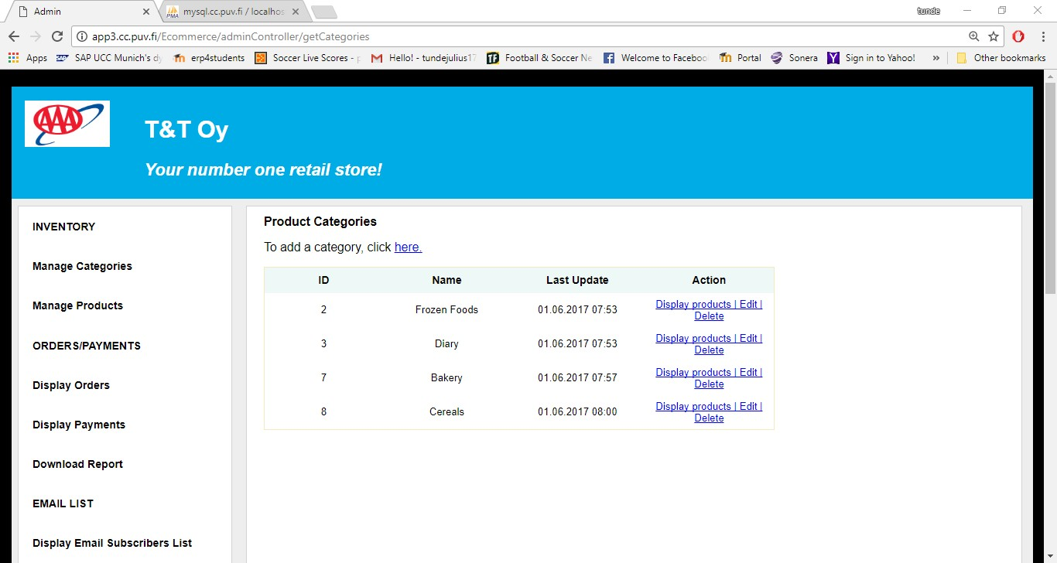

**Figure 17.** Categories page.

## Add Category Page

The page for adding product categories is shown in Figure 18. The page displays the add category form when an admin user clicks the link for adding a category on the categories page. The form checks for null and empty string values, thus, it is not possible to enter null or empty string values. The edit category form is basically the same as the add category form, except that it contains editable data in its field.

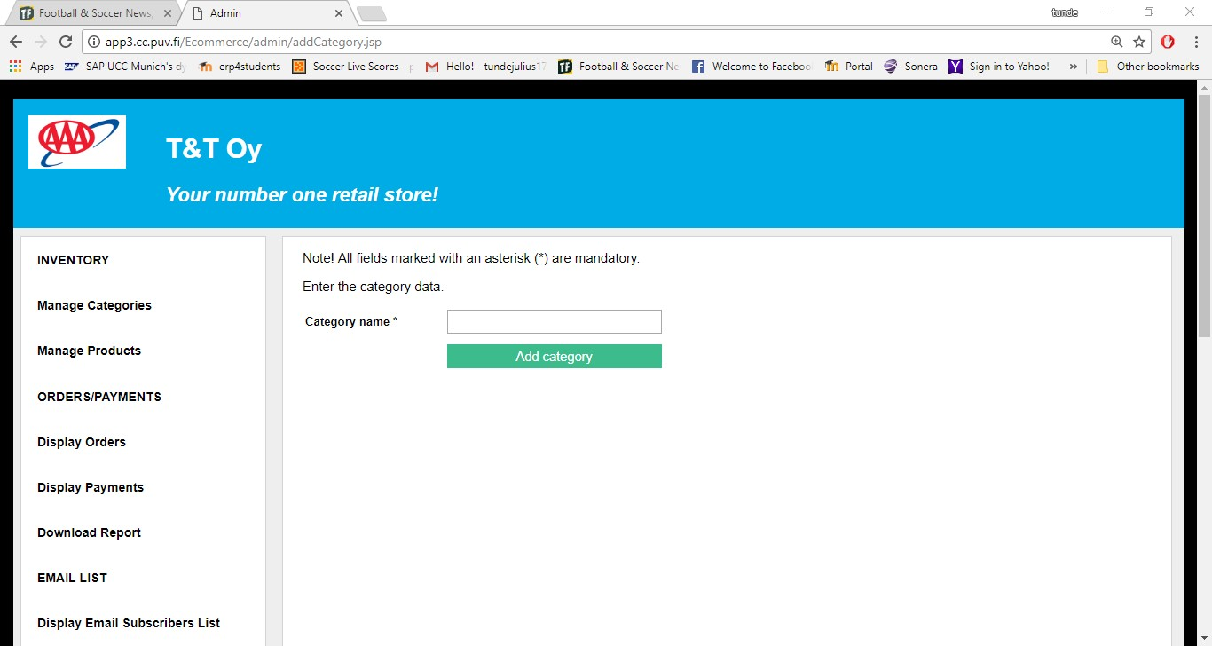

**Figure 18.** Add category page.

## Products Page

Figure 19 shows the products page of this application. It is the page for managing products of the online store and is accessed by clicking the manage products link on the admin menu page. All products of the store are displayed on this page, and each of these products has links for editing its data and deleting it from the database. Also, at the top of the page there is a link for adding products.

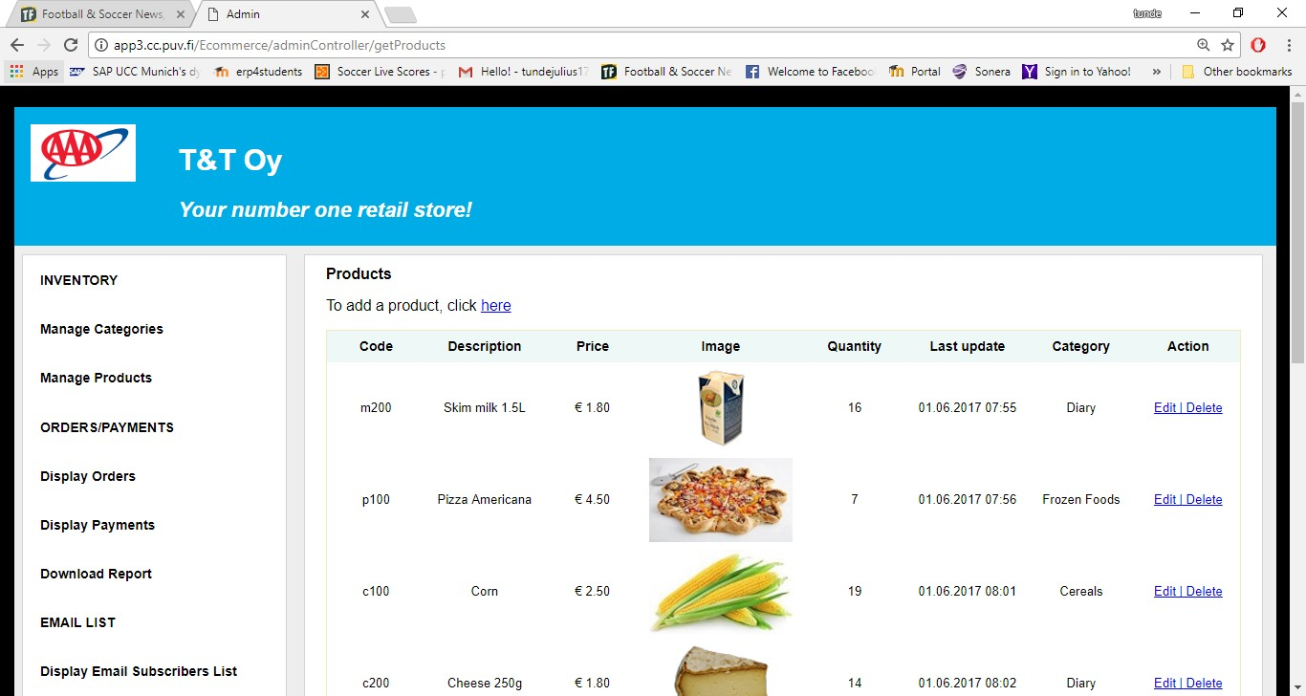

**Figure 19.** Products page.

## Add Product Page

The page for adding products is shown in Figure 20. The form on this page is displayed when the link for adding products on the products page is clicked. Every input on this form is checked for null and empty values. The edit product form is basically the same as the add product form, except that it contains editable data in its fields.

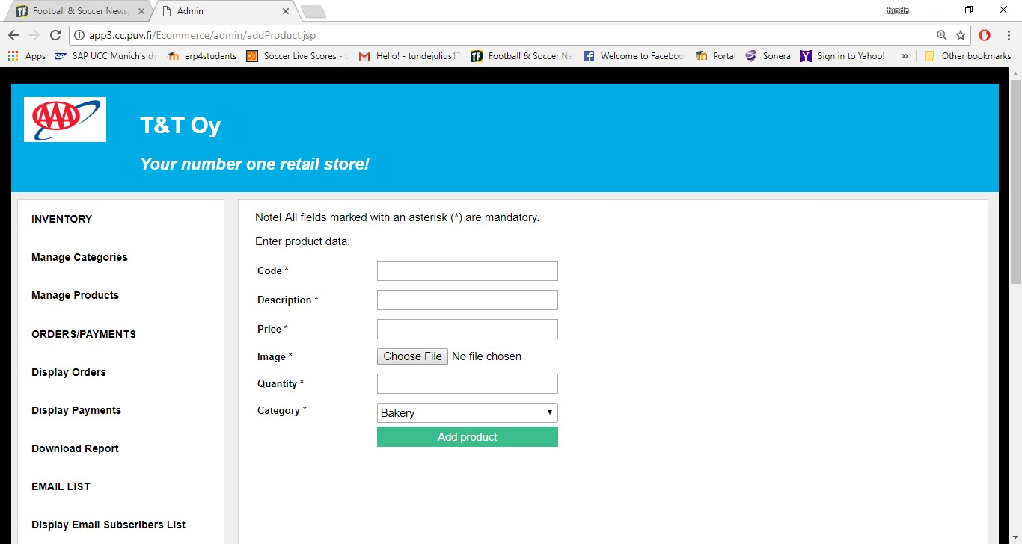

**Figure 20.** Add product page.

## Email List Page

The email list page is shown in Figure 21. The page is accessed by clicking the display email subscribers list link on the admin menu page. It displays a list of all customers and visitors to the web store who have subscribed to the email list for special announcements and offers.

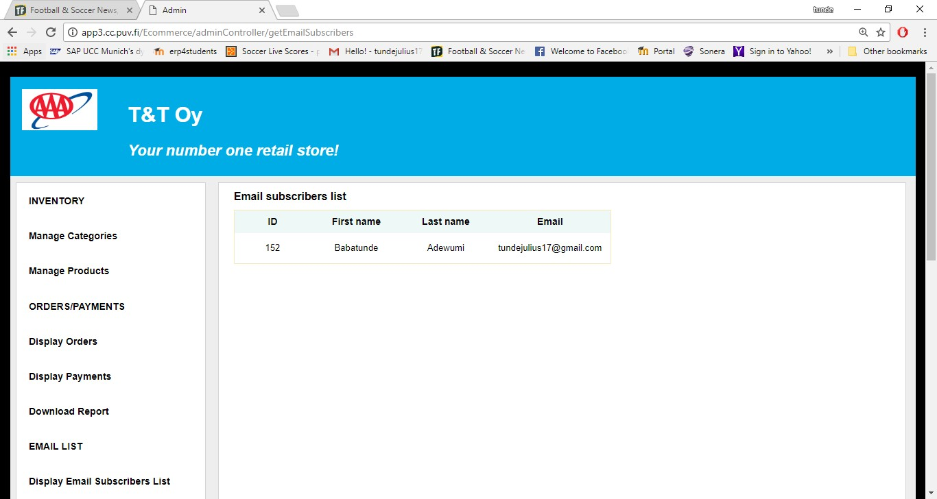

**Figure 21.** Email list page.

## Report Download Form

Figure 22 shows the report download form, which is accessed by clicking the download report link on the admin menu page. The user chooses the report to be downloaded, enters start and end dates in the given format, and clicks the download button to download the chosen report in excel format. An appropriate error message is displayed if a wrong date format is entered.

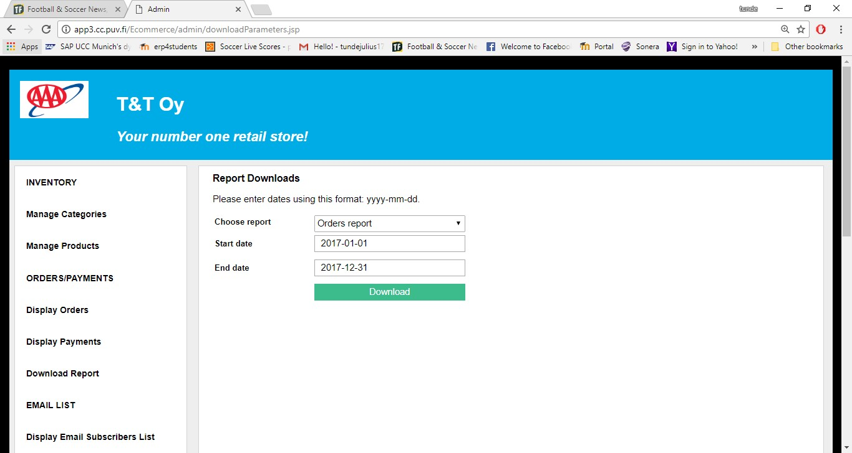

**Figure 22.** Report download form.

## Orders List Page

The orders list page is shown in Figure 23. The page is displayed when an admin user fills and successfully submits the orders report form. The page displays a list of all orders requested in accordance with the start and end dates entered on the orders report form. Also, it is possible to view details of an order by clicking the view details button. Lastly, the status of the order can be updated on the order details page.

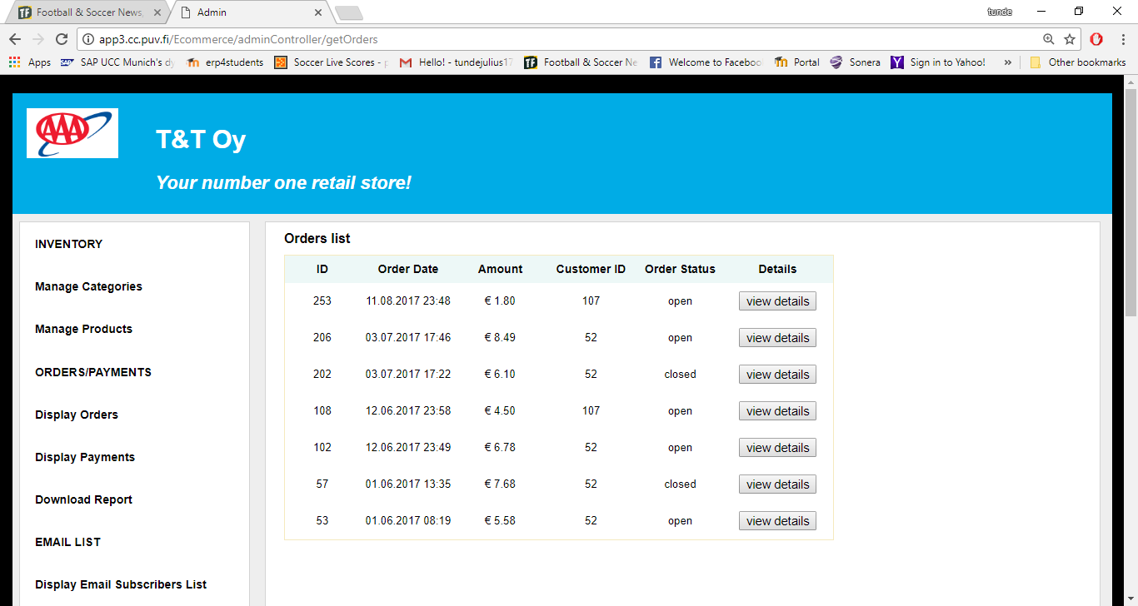

**Figure 23.** Orders list page.

## Payments List Page

The diagram in Figure 24 is the payments list page of this online retail store application. The page is accessed by filling and submitting the payment report form correctly. The page displays a list of all payment transactions in accordance with the start and end dates entered.

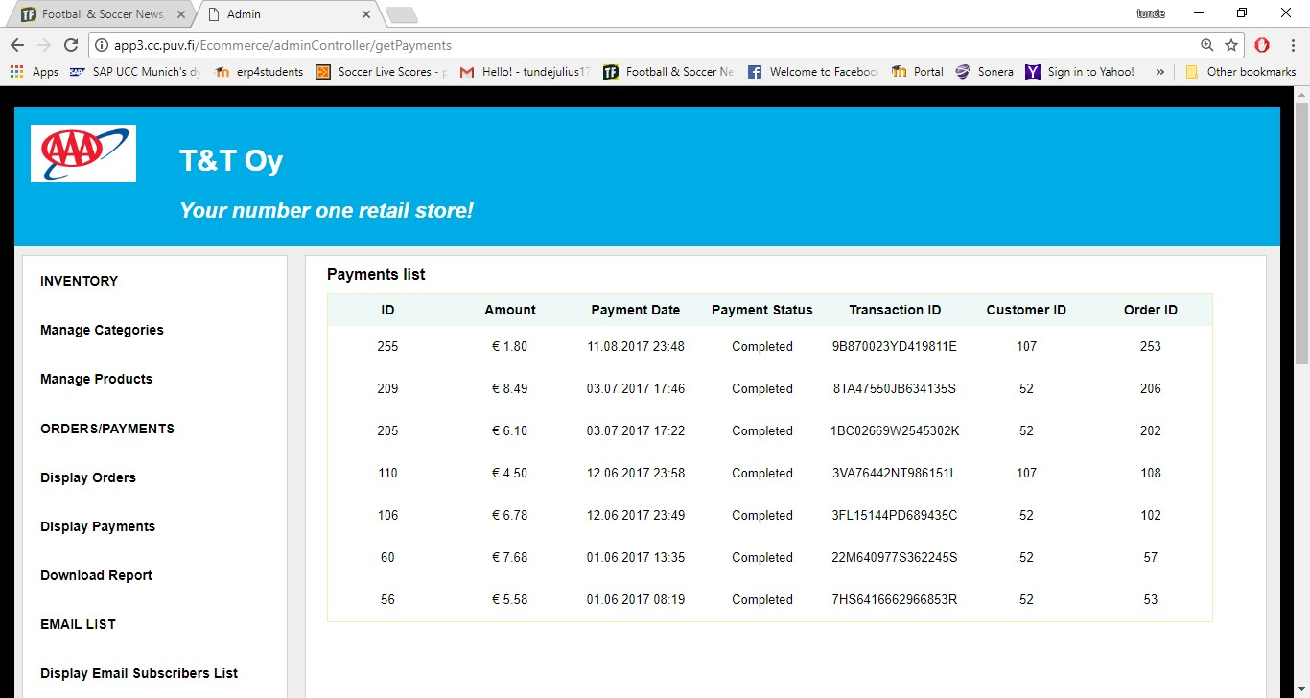

**Figure 24.** Payments list page.